PulseCare – BOOK A DOCTOR

INTRODUCTION:
PulseCare is a web-based healthcare appointment booking platform that connects patients, doctors, and administrators through a centralized portal. It is designed to simplify the process of finding a suitable doctor, reviewing professional information, and requesting a consultation online.
Patients can browse doctors by department or specialty, view profile information such as qualifications, experience, clinic, location, availability, and consultation fee, and select an appointment date and time. The booking interface also supports visit details, optional symptom information, and medical report uploads.
The platform provides separate patient, doctor, and administrator experiences. Patients can review consultations and appointment status; doctors can view their schedules and patient requests; administrators can manage doctor records, patient accounts, departments, and appointments.
PulseCare uses a React-based frontend with a Node.js and Express backend and MongoDB data storage. The supplied implementation notes show Mongoose models, JWT authentication middleware, password hashing with bcrypt, and Multer-based document upload handling.

SCENARIO BASED CASE STUDY:

Background
PulseCare is a digital appointment-management platform intended to reduce the effort involved in searching for doctors and coordinating consultations. The interface groups doctors by medical department and presents key information so patients can compare options before booking. The system also provides doctor and administrator portals for handling appointments and platform records.

Scenario
Illustrative User Persona:
Name: Sarah Jenkins
Age: 29
Role: Patient
Goal: Find a suitable specialist, compare consultation details, and reserve an appointment without repeated phone calls.

The Challenge
Sarah needs a convenient way to locate a doctor and understand the available consultation options. A disconnected process can require separate searches for specialty, clinic, availability, appointment status, and medical-document submission. She needs a single portal that can:
- Show doctors by specialty and department with relevant profile information.
- Display consultation fees and available appointment days or time slots.
- Allow appointment requests with visit reasons and optional medical-document uploads.
- Provide a patient dashboard to review upcoming, completed, and cancelled consultations.

Solution: How PulseCare Helps
PulseCare brings the appointment journey into one web application. A patient can register or sign in, search for a doctor or department, open the doctor profile, select a date and available slot, provide visit details, and submit the booking. The patient portal then presents consultation information and available actions.
- Doctor Portal: Doctors can review consultation schedules, see patient and visit information, view medical records where available, and use the provided appointment actions to manage requests.
- Administrator Portal: Administrators can oversee registered patients and doctors, review doctor approval status, maintain department information, and monitor appointments across the platform.
The supplied screenshots illustrate the main patient, doctor, and administrator interfaces, including doctor search, registration, appointment booking, confirmation, and management dashboards.

SYSTEM REQUIREMENTS:
Software Requirements:
The following software is suitable for developing, running, and testing the PulseCare web application. The list combines technologies identified in the supplied implementation notes with the tools needed for a typical local development setup.

1. Software Requirements
These tools and platforms support frontend development, backend API execution, database access, and browser-based testing.
- Operating System: Windows 10/11, macOS, or Linux — suitable for the Node.js development environment.
- Node.js: JavaScript runtime used to execute the Express backend and development tools. The supplied setup notes use a Node.js server process.
- npm: Package manager used to install and manage the client and server dependencies.
- React.js: Frontend library used to build the PulseCare pages, forms, doctor listings, and role-based dashboards.
- Web Browser: Google Chrome, Microsoft Edge, or Firefox — used to access and test the web application.
- Express.js: Backend web framework used to define REST API routes and process application requests.
- MongoDB and Mongoose: MongoDB stores application records, while Mongoose defines schemas and performs database operations.
- Postman or equivalent API client: Useful for testing registration, authentication, doctor, appointment, and administrator endpoints.
- Visual Studio Code: Code editor used for working with the client and server projects.

2. Hardware Requirements
The following specifications are practical development recommendations. Actual requirements may vary depending on the local database, browser, and tools running together.
- Processor: Intel Core i3 / AMD Ryzen 3 or better; a Core i5 or equivalent is recommended for comfortable multitasking.
- RAM: Minimum 4 GB; 8 GB or more is recommended when running the frontend, backend, database, editor, and browser together.
- Storage: At least 2 GB of free space for source files, packages, local uploads, and database files; additional space may be needed for dependencies.
- Display: 1366 × 768 or higher is recommended for viewing the dashboards and development tools.

TECHNICAL ARCHITECTURE:
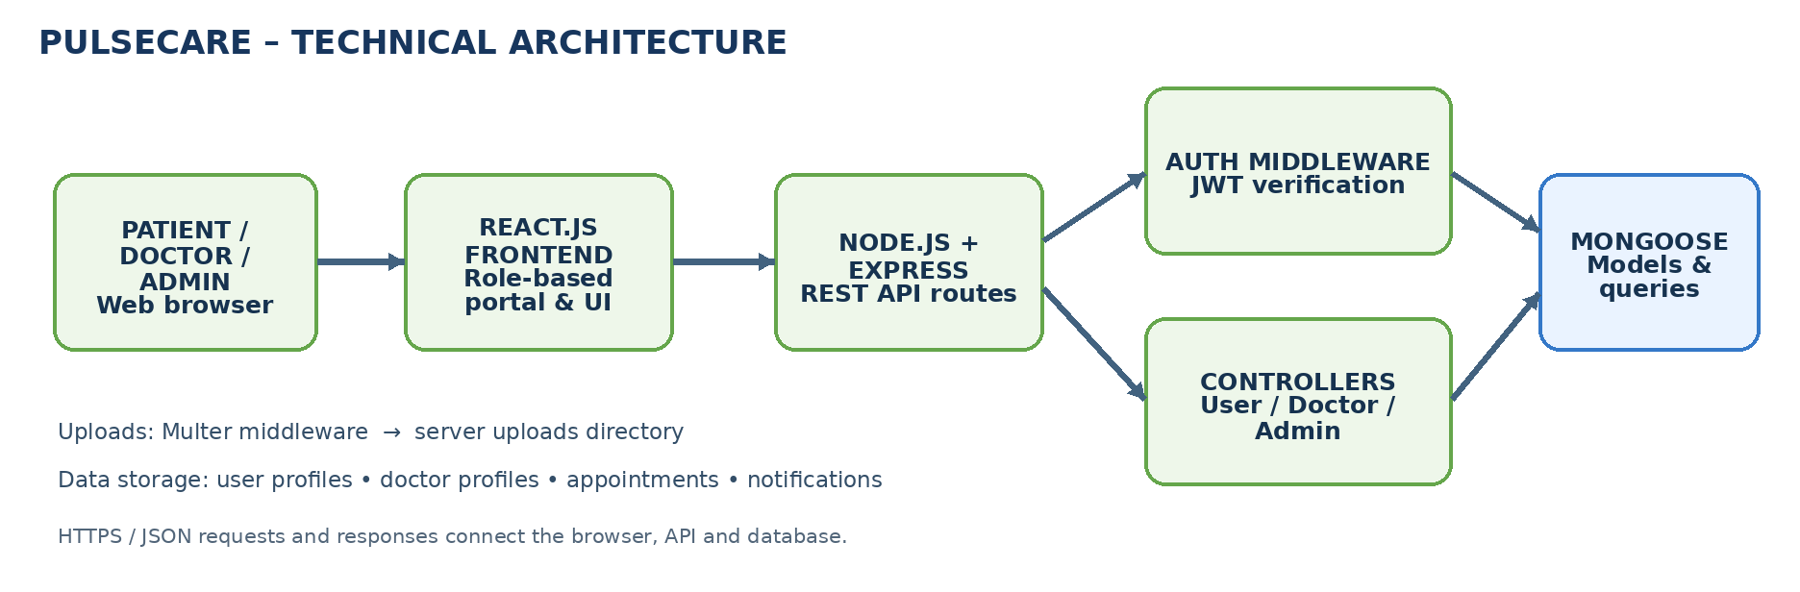

Technical Architecture Overview
PulseCare follows a client-server architecture. The browser presents the React interface, while the Express server exposes APIs for authentication, doctor information, appointments, uploads, and administrator operations. Mongoose connects the backend application to MongoDB.
User Interface (UI): The React frontend presents the public home page, doctor search and department pages, patient portal, doctor portal, and administrator dashboard. React Router is used for client-side navigation.
Web Server and API: Node.js runs the Express application. The server receives HTTP requests, applies middleware, routes requests to the relevant controller, and returns JSON responses to the frontend.
Routing and Controllers: Separate user, doctor, and administrator route groups connect API endpoints to controller functions for registration, login, profile management, appointment booking, approval actions, and data retrieval.
Authentication Service: The supplied backend notes show JWT-based authentication middleware. Passwords are hashed with bcrypt, and protected routes verify the bearer token before continuing to the controller.
Database: MongoDB stores user, doctor, and appointment records. Mongoose models define the data structures and relationships used by the controllers.
File Upload Service: Multer is used for appointment-related document uploads. The supplied implementation notes describe saving uploaded files in a server uploads directory and making them available for authorized retrieval.
Role-Based Portals: The patient, doctor, and administrator interfaces expose different workflows. The administrator interface includes doctor, patient, department, and appointment management views.
Together, these components support a centralized appointment workflow from doctor discovery and booking through doctor review and administrator oversight.
ER DIAGRAM:
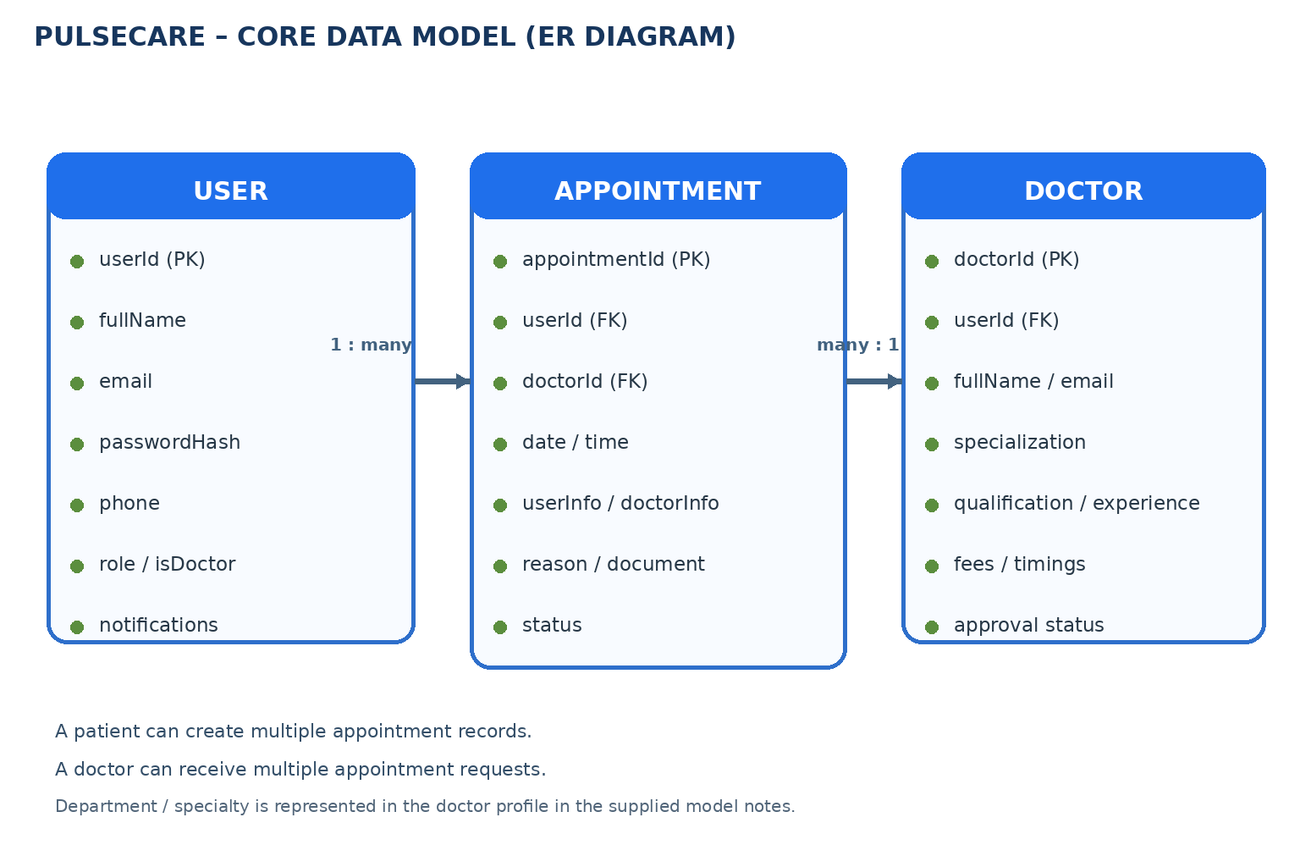

Entities and Relationships

1. User / Patient
- Represents a person registered on PulseCare. The supplied model notes include account details such as name, email, password, phone, and role-related information.
- The user profile may also contain notification information and patient details shown in the interface, such as age, gender, blood group, emergency contact, and address.
- Relationships:
  - Creates → Appointment: A patient can create multiple appointment records over time. Each appointment stores a reference to the user who requested it.
  - Receives → Notification: Appointment and account events can be communicated through the notification information associated with the user account.
2. Doctor
- Represents a medical practitioner registered on the platform. The doctor model notes include the linked user account, full name, email, phone, address, specialization, experience, fees, status, and working timings.
- A doctor profile provides the information used by the doctor listing and profile views, including department or specialty, qualifications, clinic or practice information, experience, consultation fee, and availability.
- Relationships:
  - Handles → Appointment: One doctor can receive multiple appointment requests. Each appointment stores the doctor reference and doctor information needed for display.

3. Appointment
- Represents a patient request for a consultation with a selected doctor. The supplied appointment schema notes include user and doctor references, date, user information, doctor information, document information, and status.
- Relationships:
  - Belongs to → User: Each appointment is associated with the patient who submitted the request.
  - Assigned to → Doctor: Each appointment is associated with the selected doctor who reviews or manages the consultation request.

4. Department / Specialty
- Represents the medical category used to group and discover doctors, such as Cardiology, Dermatology, General Medicine, Neurology, Oncology, Orthopedics, ENT, Gynecology, and Pediatrics.
- The latest PulseCare screenshots show department browsing and administrator department-management screens. The supplied source-code notes do not establish a separate database schema for departments; specialty information is also present in doctor profile data.
- Relationships:
  - Groups → Doctor: A department or specialty groups the doctor profiles presented to patients in the search and browse screens.
  - The core data relationships shown above are based on the User, Doctor, and Appointment models identified in the supplied code-analysis screenshots. Department is described as a visible classification and management feature.

Key Features:

1. User Registration and Authentication
- Patient and Doctor Registration: The registration interface lets a person choose a patient or doctor account type and enter account credentials. Doctor registration also collects professional and practice details for review.

2. Doctor Discovery and Department Management
- Doctor Listings and Profiles: Patients can browse doctors by department and review displayed details such as specialty, qualifications, experience, clinic, location, consultation fee, availability, and rating where shown.

3. Appointment Booking and Patient Records
- Appointment Management: Patients can select a doctor, choose an available date and time, enter the reason for visit, add optional symptom details, and upload medical reports or previous prescriptions. The patient portal displays consultation information and status.

ROLES AND RESPONSIBILITIES:
Patient:
Registration and Profile: Patients create an account and maintain basic contact and health-profile information. Doctor Discovery: Patients search by doctor name or department and review doctor profiles. Booking: Patients choose a doctor, date, time slot, and reason for visit, and may upload reports. Tracking: Patients review consultation status, upcoming or past visits, and available cancellation or report-upload actions.
Doctor:
Profile and Schedule: Doctors submit professional information and maintain their profile details. Appointment Review: Doctors access their consultation schedule and review patient information, visit reasons, and available medical records. Appointment Actions: Doctors use the portal controls to manage appointment requests and consultation status.
Administrator:
User and Doctor Oversight: Administrators view registered patients and doctor records, including account and approval status. Doctor Verification: Administrators review doctor applications and use approval or deactivation controls shown in the management interface.
Department Management: Administrators can view the department and specialty catalogue and use the provided interface actions to add, edit, or remove department entries.
Appointment Monitoring: Administrators access a system-wide appointment list containing patient details, doctor and department, date and slot, reason for visit, fee, and status.
Platform Administration: Administrators oversee the main records and management views so that patient, doctor, department, and appointment information remains organized.
Account Status: The administrator interface displays active or approval states and provides controls for managing the status of doctor and patient accounts.
Data Oversight: The dashboard summarizes visible platform information such as patient counts, doctor counts, consultation counts, and recent appointment records.
App Maintenance: The administrator role supports ongoing monitoring and maintenance of the platform. The supplied screenshots demonstrate management interfaces; operational policy and support procedures are not specified in the supplied material.

User Flow:
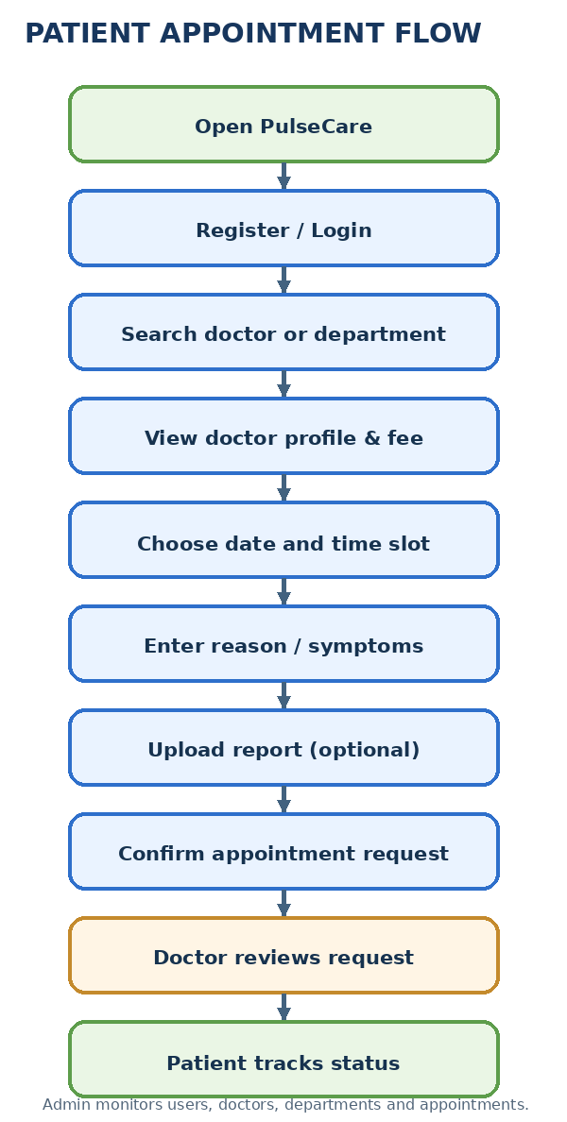
Start: The patient opens the PulseCare website and views the home page.
Register / Login: The patient creates an account or signs in. Doctor users and administrators access their respective role-based portals.
Find Doctors: The patient searches by doctor name or condition, selects a department, or browses available doctor cards.

Review Profile: The patient views doctor information such as specialty, qualification, experience, clinic, location, available days, and consultation fee.
Book Appointment: The patient selects a date and available time slot, enters visit details, and may provide symptoms or upload medical reports.

Confirmation and Doctor Review: The appointment request is submitted and a confirmation view may display the appointment identifier, doctor, date/time, fee, and status. The doctor reviews the appointment in the doctor portal.
Track and Manage: The patient checks the appointment in the patient dashboard and uses available actions such as viewing details, uploading reports, or cancelling where supported.

MVC PATTERN:

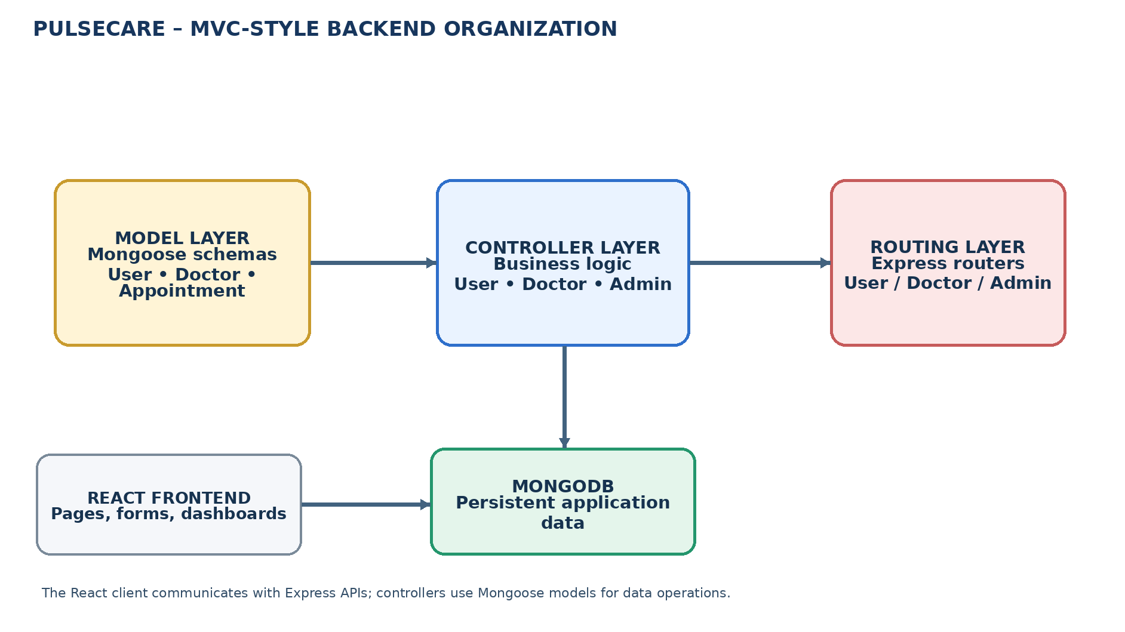

The backend is organized in an MVC-style structure using Mongoose models, Express controllers, and Express route files. The React frontend acts as the client-side view layer. This separation keeps data definitions, request handling, and user-interface rendering in distinct parts of the application.
Model Layer (Data Layer)
The model layer defines the MongoDB data structures through Mongoose schemas and models. The supplied source notes identify User, Doctor, and Appointment models. These models are used to create, retrieve, update, and relate the records required for appointment management.
Controller Layer
Controller functions process application requests and perform the required operations. The supplied notes identify user-related controllers for registration, login, doctor applications, appointments, and notifications, doctor controllers for profile and appointment actions, and administrator controllers for user, doctor, and appointment management.
View Layer (Routing and React UI)
Express route files define the API endpoints and connect them to controller functions. The React frontend provides the visible pages and forms for patients, doctors, and administrators. Axios is used in the supplied frontend notes for API requests.
Advantages of This Organization
- Separation of Concerns: Models, controllers, routes, and React pages have distinct responsibilities, making the application easier to understand and maintain.
- Scalability: Additional doctor, appointment, or administrative features can be added through new or extended routes, controllers, models, and frontend components.
- Reusability: Shared authentication middleware, model operations, and reusable React components can support more than one workflow.
- Testing: API routes and controller operations can be tested separately from the frontend interface.
- Maintainability: A modular structure makes it easier to locate application logic and update individual features.

Project Setup And Configuration:
- Creating the project folder
1. Create or open the PulseCare project root folder.
2. Keep the frontend client and backend server in separate folders.
3. The frontend folder is referred to as client in the supplied setup notes.
4. The backend folder is referred to as server in the supplied setup notes.
5. Open the project root in Visual Studio Code and use separate terminal sessions for the client and server.
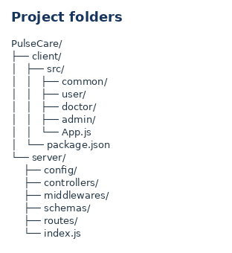
- Client setup (React application)
  - Open a terminal in the client folder.
    - Install the client dependencies using npm install.
  - The supplied frontend notes identify React as the client framework.
    - Start the frontend development server:
    - npm run dev
  - Open the local URL printed by Vite in the terminal.
    - The earlier setup screenshot shows the client running at:
    - http://localhost:5173
  - Keep the frontend terminal running while testing the application.
    - Server setup (Express application)
  - Open a second terminal in the project root.
    - Navigate to the server folder:
  - cd server
    - Install the server dependencies with npm install, if they are not already installed.

- Configure and start the backend
  - Create or update the server environment file using the variable names expected by the project.
    - Set the MongoDB connection string in MONGO_URI and set the JWT secret in JWT_KEY. Do not commit real secrets to source control.
  - The supplied backend package notes identify index.js as the server entry point.
    - Start the backend using the configured npm script or the documented development command.
  - The supplied setup notes show nodemon index.js for development.
    - Confirm that the backend reports a successful database connection.
    - The setup screenshots show the backend API at localhost:8000.
    - Use the browser to access the frontend and verify that API requests reach the backend.

Backend Structure:
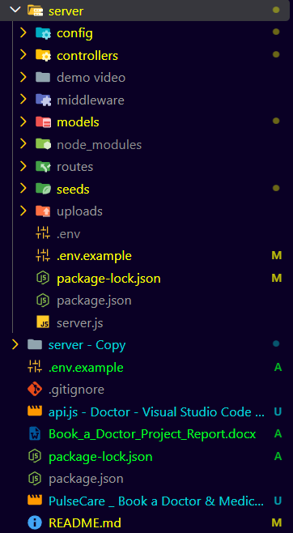

server/
config/
connectToDB.js – Connects the Node.js backend to MongoDB through Mongoose using the MONGO_URI environment variable.
controllers/
- userC.js – Handles user registration, login, authentication-related data, doctor application, appointment booking, and notification operations as described in the supplied controller notes.
- doctorC.js – Handles doctor profile updates, doctor appointment retrieval, appointment status changes, and document download operations.
middlewares/
- authMiddleware.js – Reads the bearer token, verifies the JWT with the configured secret, and makes the decoded user identifier available to protected routes.
schemas/
appointmentModel.js – Defines the appointment schema with user and doctor references, date, document, and status fields.
userModel.js and docModel.js – Define user-account and doctor-profile data, including the doctor’s user reference and professional information.
routes/
- UserRoutes.js – Defines user registration, login, profile, doctor listing, appointment, notification, and document-related API endpoints.

- DoctorRoutes.js and AdminRoutes.js – Define protected routes for doctor profile and appointment actions and administrator user, doctor, approval, and appointment management.
index.js – Backend entry point identified in the supplied server package and setup notes.
The server initializes Express, loads environment variables, connects to MongoDB, registers middleware and route groups, and listens on the configured port.
DATABASE DEVELOPMENT:

1. Configure MongoDB and Mongoose:

- Install Mongoose as a server dependency if it is not already installed.
In the server project directory, run:
npm install mongoose
- Create the MongoDB connection module and load the connection string from the environment.
- Define Mongoose schemas and models for users, doctors, and appointments.

Create Database Connection:
The backend must connect to MongoDB before performing database operations. The supplied code screenshot shows Mongoose connecting through process.env.MONGO_URI and handling connection errors.

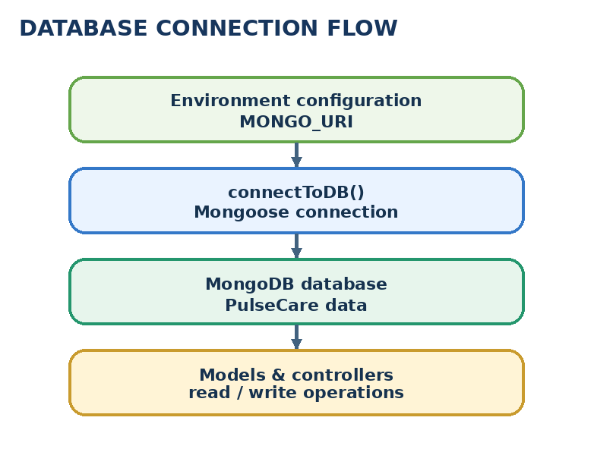

Create Schemas and Models:

The model fields should follow the application data represented in the supplied source notes. The main collections are users, doctors, and appointments. The appointment records link the patient and doctor and store the selected date, document information, and status.

appointmentModel.js – Defines the Mongoose schema for an appointment, including userId, doctorId, date, userInfo, doctorInfo, document, and status fields.
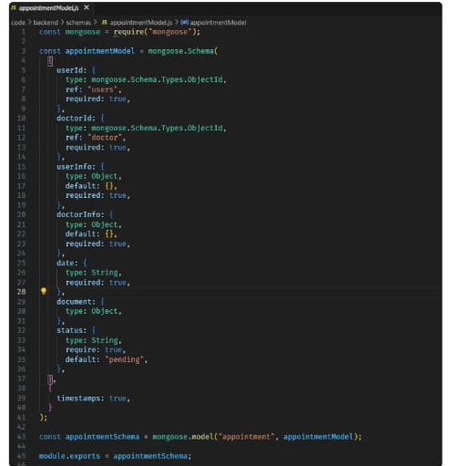

docModel.js / userModel.js – Store doctor professional details and user account details. The doctor profile is linked to the user account through a userId reference.

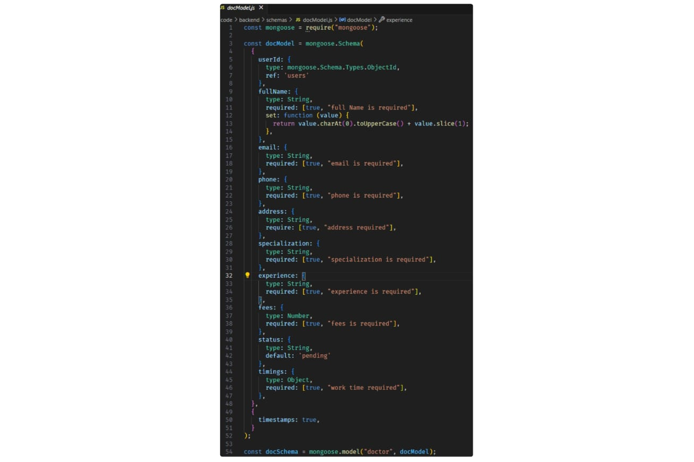

Frontend Structure:
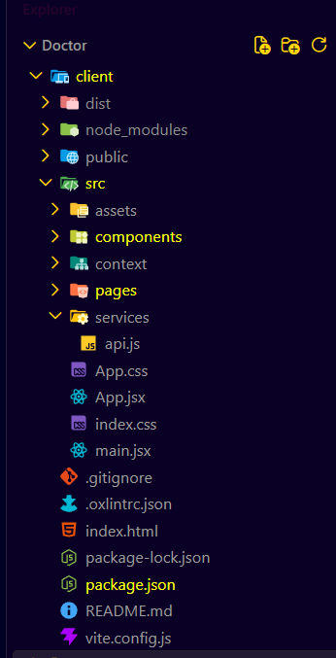

client/

src/

common/
Contains shared pages and reusable interface elements used throughout PulseCare.

common / shared pages
- Home.jsx – Displays the public PulseCare landing page and doctor search entry point.
- Navbar and shared layout – Provide navigation between Home, Find Doctors, Departments, role portals, and logout controls.
- DoctorList.jsx – Displays doctor cards and profile information with booking actions.
- Login.jsx and Register.jsx – Provide account sign-in and patient/doctor registration forms.
- App.js – Main React application component and route/layout entry point shown in the source notes.
- ApplyDoctor.jsx – Provides the doctor application or professional registration workflow where used.

Role-based components
Reusable UI components support doctor cards, forms, navigation, appointment details, and dashboard elements.

user/
- UserHome.jsx – Presents the patient portal, profile and health information, consultations, and appointment actions.
- Notification.jsx – Displays notification information and supports notification actions described in the source notes.

doctor/
- DoctorHome.jsx – Presents the doctor portal and consultation schedule.
- AdminHome.jsx – Presents the administrator dashboard and management sections.
- AdminAppointment.jsx – Fetches and displays appointment information for the administrator view.
- DoctorList.jsx and appointment components – Support doctor discovery and the booking interaction.

Root Files/
- CSS and static assets – Provide application styling, images, icons, and other interface resources.
- App.js – Main component that connects application routes and page components.
- Global stylesheet – Defines shared styles used across the React interface.
- Client entry point – Renders the React application in the browser.
- Environment configuration – Stores frontend configuration such as the backend API base URL; do not expose secret values.
- package.json – Lists frontend dependencies and npm scripts.
- The file names above are drawn from the supplied implementation notes and screenshots; verify exact casing against the final source repository before deployment.
OUTPUT SCREENSHOTS:Home Page:
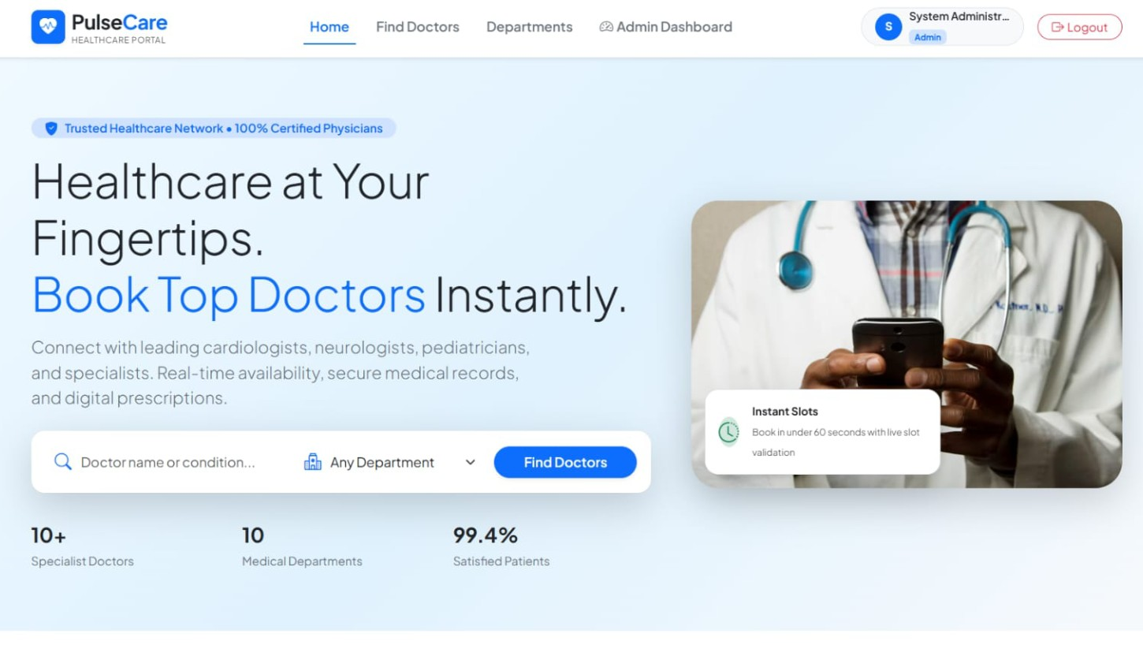
Patient Registration Page:
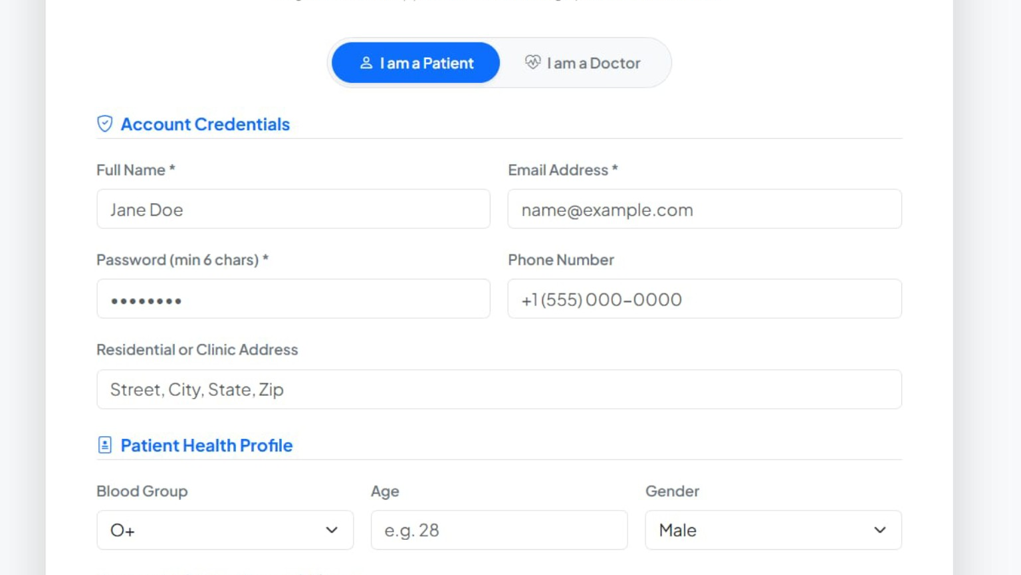

Doctor Registration Page:
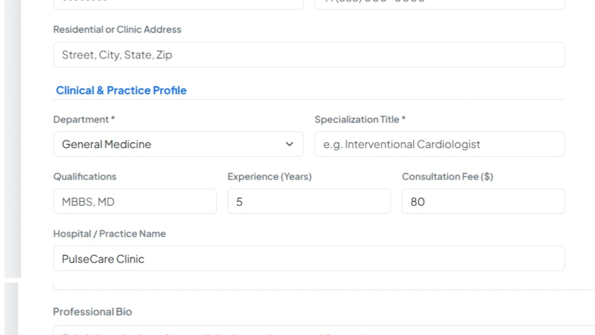

Find Doctors Page:

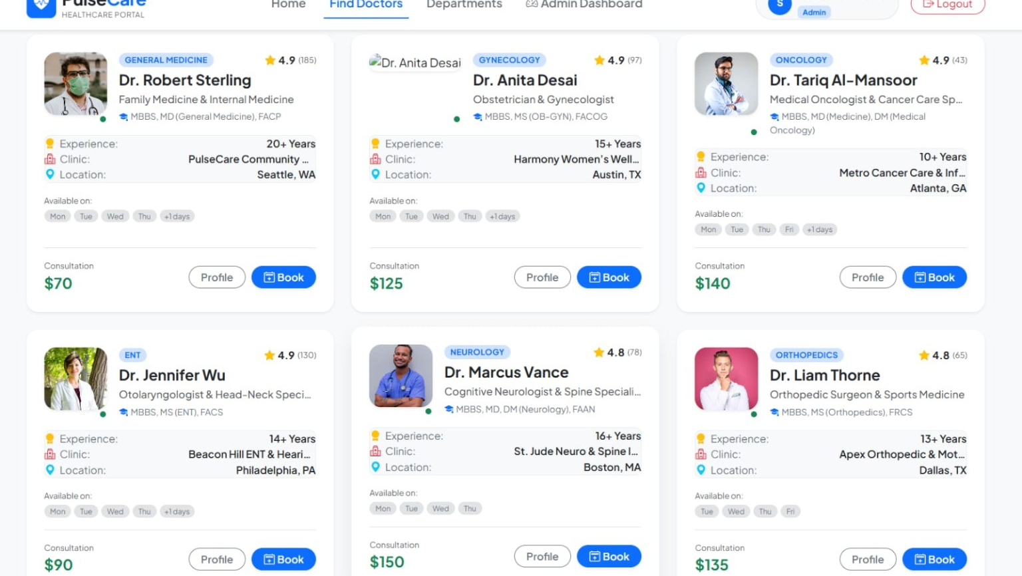

Patient Dashboard:

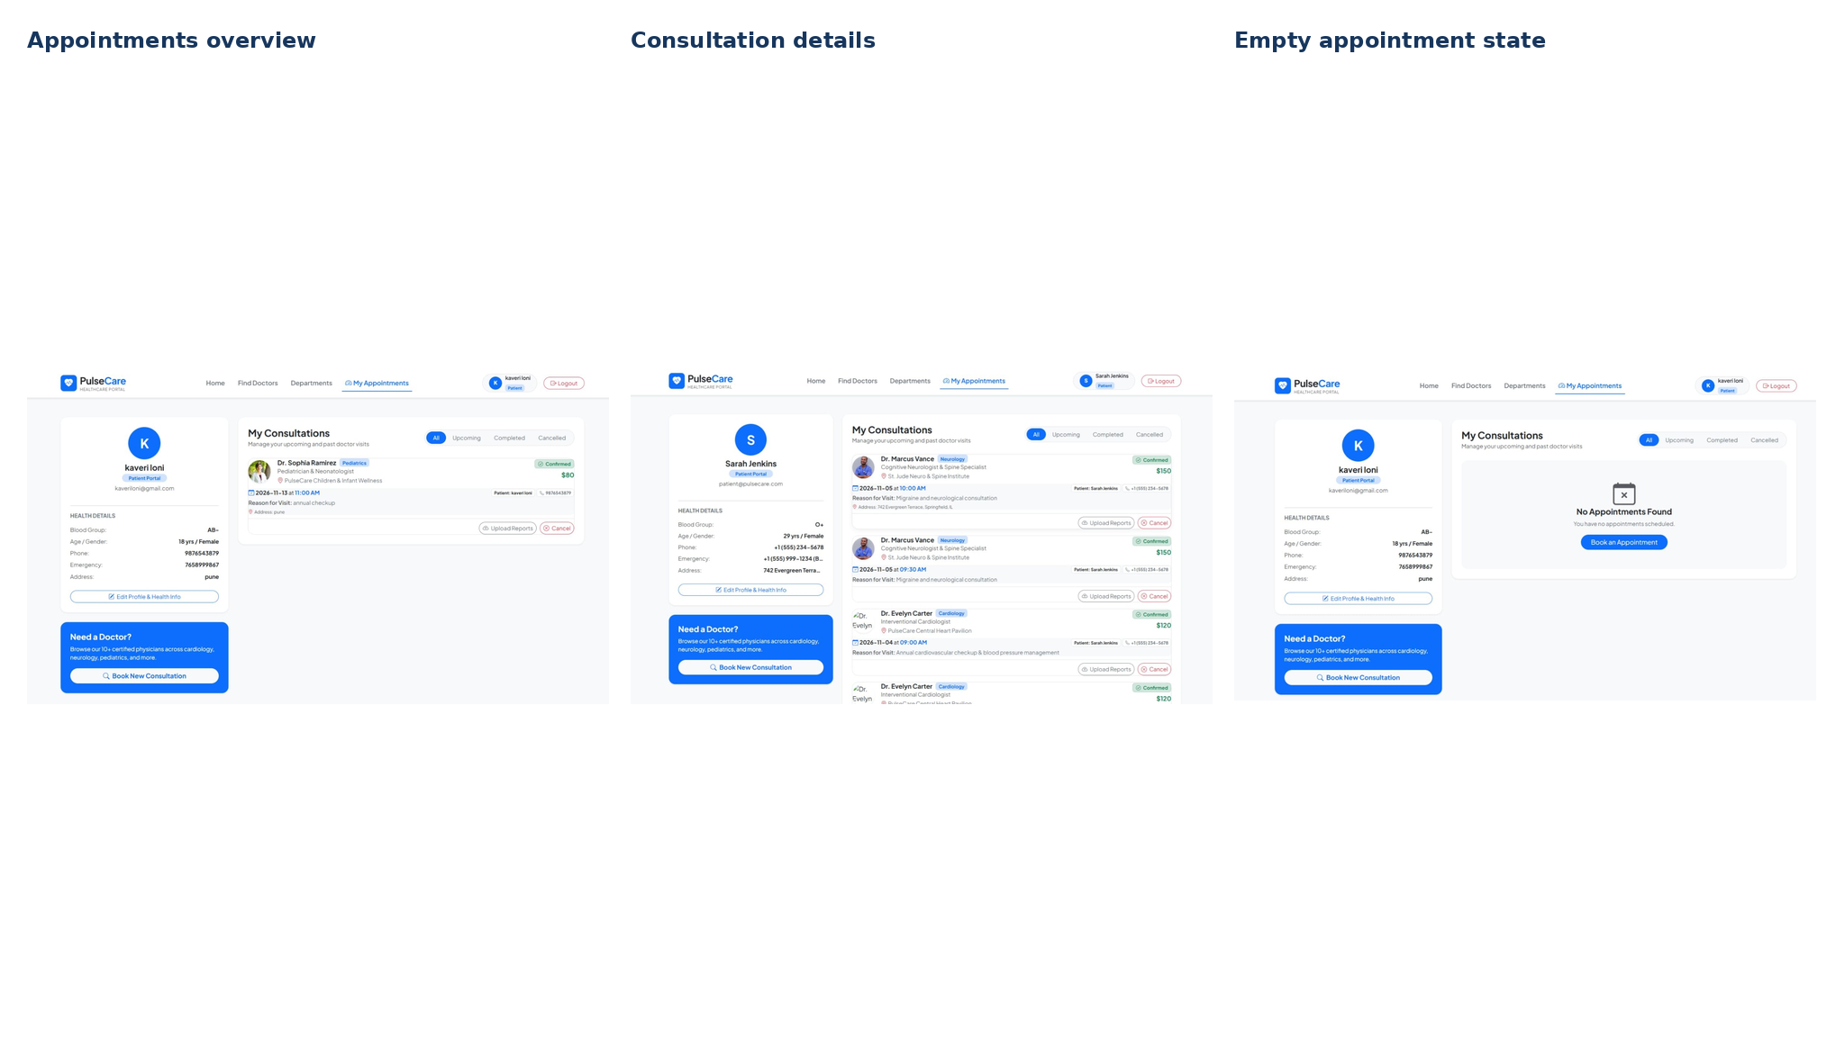

Doctor Dashboard:

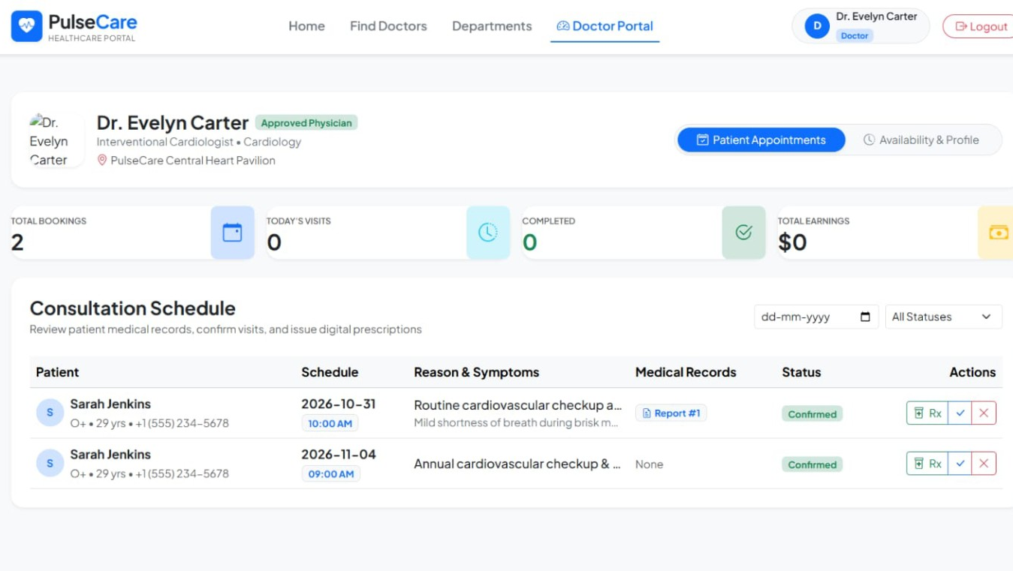

Administrator Dashboard and Management:

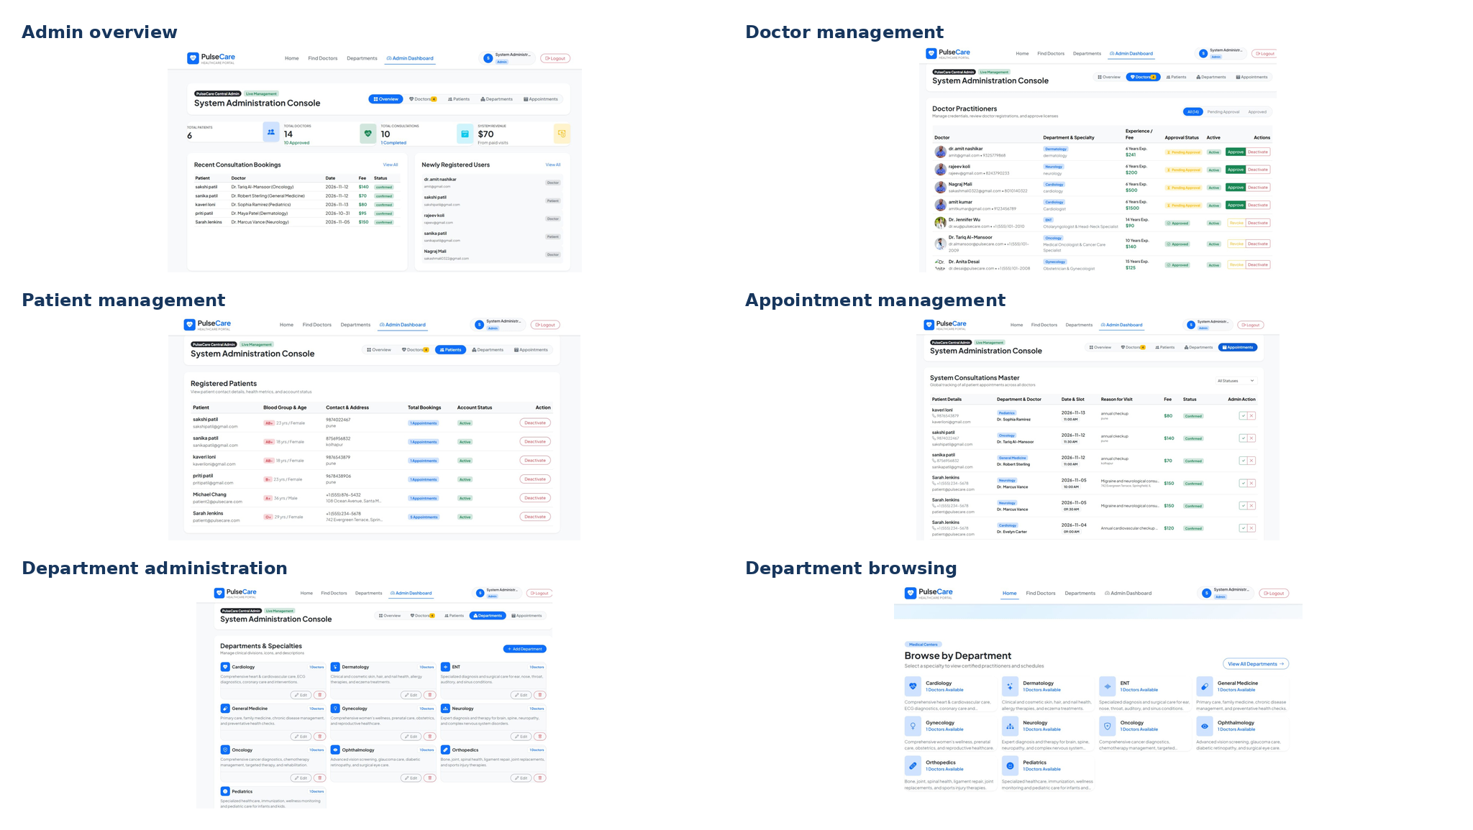

Appointment Booking and Confirmation:

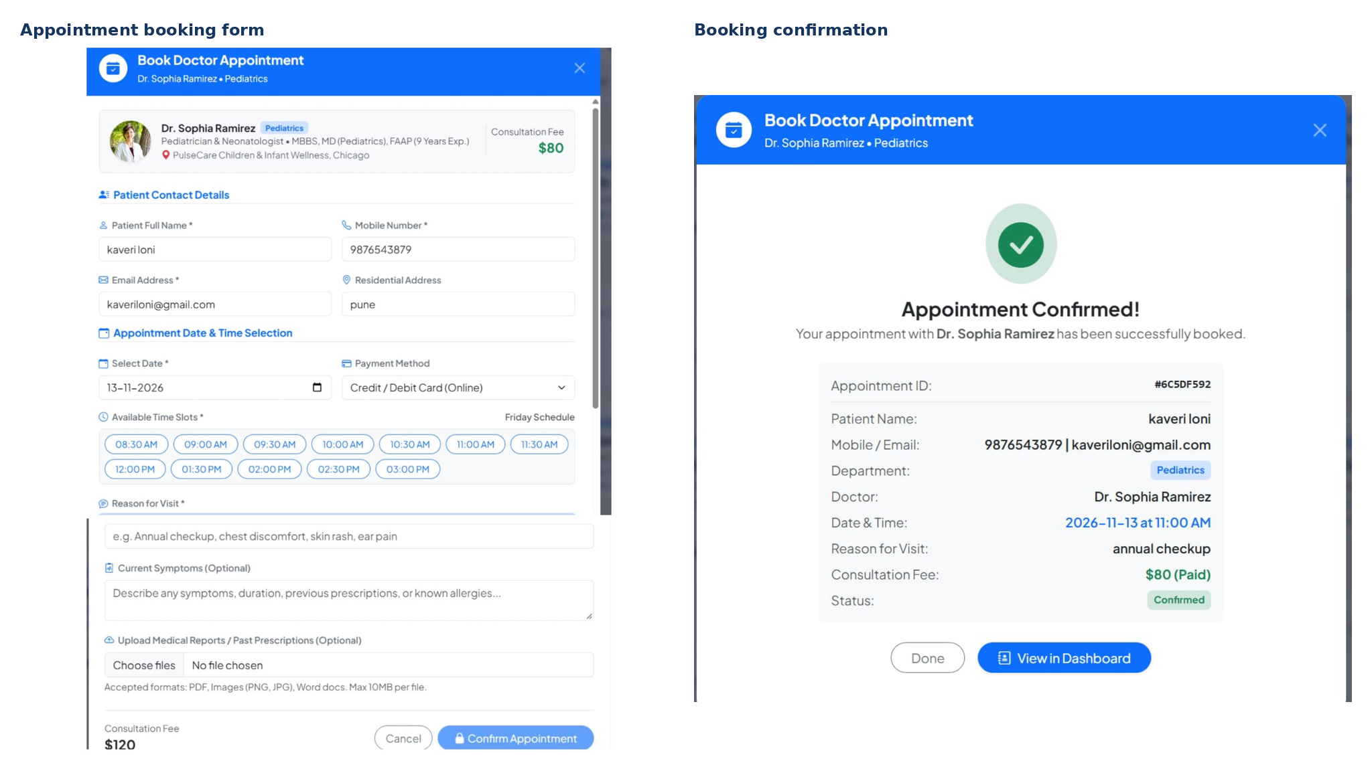

PROJECT SUMMARY:
PulseCare provides a unified healthcare appointment workflow. Patients can register, search doctors and departments, review consultation information, request appointments, and view their consultations. Doctors can review scheduled visits and patient information, while administrators manage doctor records, patient accounts, departments, and appointment records. The project combines a React frontend with Express APIs, MongoDB data storage, Mongoose models, and JWT-based route protection as described in the supplied implementation notes.
KEY PROJECT CAPABILITIES:
• Patient registration and profile management
• Doctor discovery by department and specialty
• Appointment date/time selection and booking details
• Doctor consultation schedule and appointment actions
• Administrator management of doctors, patients, departments, and appointments
FUTURE ENHANCEMENTS:
Possible future improvements include verified online payment-gateway integration, automated appointment reminders, secure teleconsultation, digital prescription management, and expanded reporting. These are suggested extensions and are not claimed as verified current features.
DOCUMENTATION NOTE:
The report uses the supplied implementation notes and PulseCare interface screenshots. A public deployment URL, source repository URL, and payment-gateway implementation details were not included in the supplied materials.

Demo Video Link:
https://drive.google.com/file/d/1tsn-_7nNAoeOeb_6uqbZR4m_adiLJKXs/view?usp=sharing
Github Link:
Not provided in the supplied project materials.

